Focused Inbox in Office 365 Email

Guide to Identifying & Toggling Off/On | November 23, 2021

Office 365 has an email feature called “Focused Inbox.” If your Focused Inbox is activated, Office 365 automatically routes and delivers your emails into either the “Focused Inbox” or the “Other Inbox.”

If you cannot find an email you were expecting, it may have been delivered to the “Other Inbox.”

Identifying Focused Inbox

If you see two tabs at the top of your TriHealth email inbox, click on “Other.”  
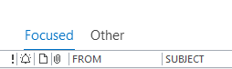

Toggling Focused Inbox Off/On

If you want to turn your Focused inbox off or on, click on the “View” and click “Show Focused Inbox” to toggle it on and off.  
